MINI CALCULATOR

NAME : SUDHARSAN K
REGISTER NO: 711525BCS167
CLASS: CSE-A
SUBJECT: C PROGRAMMING

INTRODUCTION
- This project is a small calculator program in C that can evaluate expressions like 6+2*6 or 7+9*8.
- It reads the expression as a string and calculates the answer by correctly handling addition, subtraction, multiplication, and division.
- The program uses a custom evaluate() function to process each number and operator and then prints the final result.
- This calculator follows operator precedence (BODMAS) using a logic that first handles multiplication and division before addition and subtraction.

APPLICATIONS
The Expression Calculator can be used to:

- Quickly evaluate simple math expressions
- Demonstrate operator precedence in C
- Understand evaluation logic in compilers/interpreters
- Help students build logic-based coding skills
- Serve as an academic mini project

ALGORITHM
Step 1: Start
Begin the program and declare all necessary variables and function prototypes.
Step 2: Input the Expression
Ask the user to enter a mathematical expression without spaces
Step 3: Validate Input Characters
For each character in the input:
- Check if it is a digit, operator (+, -, *, /), parenthesis (, ), or decimal point.
- If any invalid character is found → show error and stop.
Step 4: Set Pointer
- Point the global pointer expr to the input expression.
- Parsing Begins (Recursive Descent Parser)

Step 5: Parse Expression (parseExpression)
- Call parseTerm to get the first term.
- While the next character is + or -:
- Note the operator.
- Move to the next character
- Parse the next term.
- Add or subtract it from the result.
Step 6: Parse Term (parseTerm
- Call parseFactor to get the first factor.
- While the next character is * or /:
- Note the operator.
- Move to the next character.
- Parse the next factor
- Multiply or divide accordingly.
- If division by zero → show error and stop.
Step 7: Parse Factor (parseFactor)
- If the current character is (:
- Skip (.
- Call parseExpression.
- Expect ); if missing → show error.
- Otherwise:
- Call parseNumber.
Step 8: Parse Number (parseNumber)
- Initialize number as 0.
- Read all digits of the integer part.
- If a decimal point is found:
- Read digits of fractional part.
- Add fractional value to the number.
- If a number is not properly formed → show error
- Final Steps
Step 9: Check End of Expression
If there are leftover characters after parsing → show "Unexpected character" error.
Step 10: Display Result
Print the final computed value.
Step 11: End the Program

SOURCE CODE
#include <stdio.h>
#include <ctype.h>
#include <stdlib.h>

char *expr;

float parseExpression();
float parseTerm();
float parseFactor();
float parseNumber();

float parseNumber() {
float num = 0, frac = 0;
float factor = 0.1;
if (!isdigit(*expr) && *expr != '.') {
printf("Error: Expected a number at '%c'\n", *expr);
exit(1);
}

while (isdigit(*expr)) {
num = num * 10 + (*expr - '0');
expr++;
}

if (*expr == '.') {
expr++;
if (!isdigit(*expr)) {
printf("Error: Invalid decimal number\n");
exit(1);
}
while (isdigit(*expr)) {
frac += (*expr - '0') * factor;
factor /= 10;
expr++;
}
num += frac;
}

return num;
}

float parseFactor() {
if (*expr == '(') {
expr++;
float result = parseExpression();
if (*expr == ')') expr++;
else {
printf("Error: Missing closing parenthesis\n");
exit(1);
}
return result;
} else {
return parseNumber();
}
}

float parseTerm() {
float result = parseFactor();
while (*expr == '*' || *expr == '/') {
char op = *expr;
expr++;
float next = parseFactor();
if (op == '*') result *= next;
else {
if (next == 0) {
printf("Error: Division by zero\n");
exit(1);
}
result /= next;
}
}
return result;
}

float parseExpression() {
float result = parseTerm();
while (*expr == '+' || *expr == '-') {
char op = *expr;
expr++;
float next = parseTerm();
if (op == '+') result += next;
else result -= next;
}
return result;
}

int main() {
char input[100];

printf("Enter expression: ");
scanf("%s", input);

for (int i = 0; input[i]; i++) {
if (!isdigit(input[i]) && input[i] != '+' && input[i] != '-' &&
input[i] != '*' && input[i] != '/' && input[i] != '(' &&
input[i] != ')' && input[i] != '.') {
printf("Error: Invalid character '%c' in expression\n", input[i]);
return 1;
}
}

expr = input;
float result = parseExpression();

if (*expr != '\0') {
printf("Error: Unexpected character '%c'\n", *expr);
return 1;
}

printf("Result: %.5f\n", result);

return 0;
}

SAMPLE OUTPUT
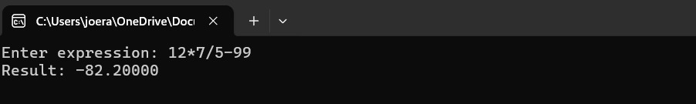
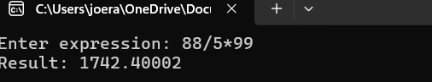
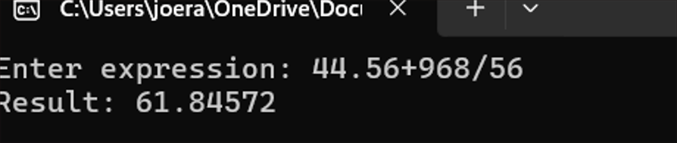
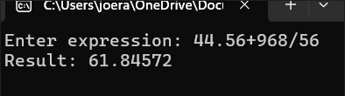
CONCLUSION
This mini project demonstrates how expressions can be evaluated in C using logic similar to compilers.
The project helps students understand:
- Parsing techniques
- Operator precedence
- String handling
- Efficient logical design
It is simple, effective, and suitable for beginners in programming.

